**Residential Rental Property Inspection Pilot Program**

**Clifton Heights Business Association Comments**

**10.17.19**

10.23.19 (City Response)

10.24.19 (CHBA Response)

10.25.19 (City Response)

The CHBA held its regular monthly meeting on October 17th and on the agenda was discussion of Councilmember Landsman’s proposed Residential Rental Property Inspection Program. We are supportive of the Councilmember’s goals and objectives as stated in his written summary; however, after reviewing the draft legislation, we believe that there are several modifications that need to be made in order to align with those stated goals and objectives.

**What properties are impacted by this program initially?**

Two sections of the legislation produce different answers to this question. The one-page program summary provided by Councilmember Landsman is much clearer in its intent and we would like to see that reflected in the legislation. The issue is as follows:

* *Section 1127-07.7 – Applicable Properties: Residential Rental Properties*

This section lists 9 different criteria in order to be included in the program and requisite inspections. We believe these criteria and triggers for inclusion in the program are reasonable.

* *Section 1127-07.9 – Rental Inspection Certificate Application Process*

Whereas the previous section noted above seems to clearly state that only substantially negligent property owners would be subject to inspection, this section seems to suggest that ALL Residential Rental Properties are subject to inspection.

Specifically, it states “all owners and persons in control of Residential Rental Properties as that term is defined in section 1127-07.1-R of this Section in the pilot residential areas shall apply for a rental inspection certificate under this section within thirty (30) days of enactment of this ordinance.”

* *One-Page Summary “Proposed City of Cincinnati Rental Inspection Program”*

“Property owners and landlords who keep their properties in good repair and code compliant are not subject to the program.”

The intent and application process outlined in the One-Page Summary are very clear. The 9 “triggers” in Section 1127-07.7 are very clear and reasonable. The program is meant to address chronically negligent property owners.

However, Section 1127-07.9 is clearly stating that ALL property owners of Residential Rental Property must apply for a rental inspection certificate and pay the requisite $100 fee. We are adamantly opposed to this interpretation and it conflicts directly with the stated intent.

You are correct that the program does not include all rental properties within the three pilot areas. The program will only include those that meet one or more of the nine triggers outlined in the ordinance. Section 1127-07.7 identifies that the proposed program will apply only to those Residential Rental Properties that (1) meet the criteria for being considered a rental; (2) are within the pilot area; and (3) meet one of the nine criteria (e.g., has been the subject of litigation or has multiple code violations). All other provisions within the ordinance refer to those properties that fit within the established parameters. The explicit provision of Section 1127-.07.7, which identifies the properties this program applies to, is clear and unambiguous about the intent to only require applications for properties that meet this Section’s criteria.

Thank you for the clarification.

**What notice does this program afford impacted property owners?**

Currently, Section 1127.07-9 (a) does not require any notice be given to impacted property owners and only states that they must apply within 30 days of enactment of the legislation. It is not reasonable to assume all impacted property owners are aware of this legislation and therefore, we believe formal notice must be given by the City. Such notice should include reference to the new legislation as well as which trigger in 1127-07.7 was violated causing their inclusion in the program.

We would instead like to see Section 1127.07-9 (a) read “All owners and persons in control of Applicable Properties as defined in Section 1127.07-7… shall apply for a rental inspection certificate under this section within thirty (30) days of being notified by the City of Cincinnati of their inclusion in the program.”

This change would address BOTH the issue of proper notice AND the issue of which properties are impacted.

The City will implement a significant outreach program to those that qualify for the program. The ordinance has a 183-day enactment after the passage of the ordinance. During that time, the City will notify property owners that their property will be subject to inspection and will also provide a self-inspection checklist and the contact information of the assigned inspector to schedule their inspection. The owner can then work toward abating any outstanding issues prior to the scheduled inspection, therefor qualifying for the 4-year license tract.

Thanks for the clarification.

**What type of fees may be incurred as part of this program?**

Section 1127-7.17 is too open ended in its ability to assign fees to property owners. It allows for fees beyond the stated inspection fees to be charged for an open-ended list of third-party experts and “administrative” overhead by the department itself.

We are comfortable with third party experts such as engineers being retained for specific issues that need additional clarity and for that expense to be placed on the property owner; however, they need to be spelled out in the legislation specifically and with a clause to the effect of “as reasonably necessary”.

This would seldom, if ever apply. An example where this could be applied is if an owner is ignoring the effects of an active hillside. The City would then bring in an engineering expert to determine the best way to fix the issue and stabilize the hill. This would also apply if there are apparent life-safety issues found in the unit or building. The costs would then be put back on the owner of the property as a first priority lien.

Completely agree. These 3rd party costs are absolutely necessary and reasonable. We would like to see some language added that justifies when a 3rd party expert is warranted in case of a dispute.

Another example of this scenario would be if the floor joists are failing and B&I indicates an engineer would need to be hired to design a plan to stabilize the structure and the owner is unable or unwilling to do so.

The need for a design professional when doing repairs or alterations to a building is dictated by the existing permitting structure in the City, which is governed by the adopted State building codes.

We are not comfortable with additional fees being added for the “administration and enforcement of this inspection program”. In our eyes this is what the inspection fee is intended to cover.

The fees associate with the inspection program are outlined in section 1127-07.19. The fee structure is meant to cover the cost of staff and administration of the program. Section 1127-07.17 simply reflects the City’s existing authority under Ohio state law (Ohio Revised Code 715.26 and 715.261) to recover costs (money it actually expends) incurred in investigating and/or resolving code violations on privately owned property.  The fees are intended to cover the administration of this program, but they will not be sufficient to cover unforeseeable and rare instances where the City incurs actual costs when a third-party contractor is required to abate code violations at the property.  Such situations occur infrequently, but prior examples include an out-of-state landlord’s failure to retain a property manager or address housing code violations that impact tenants’ health and/or safety, and a rental property owner suddenly passing away without a succession plan.

Wouldn’t those expenses identified fall into the same category as the 3rd party experts listed previously in the legislation? Hiring a property manager or contractor as noted are absolutely reasonable and desirable. The language we are questioning is “administration and enforcement” which is different.

Administration and enforcement of this program is associated with specific costs for impacted properties that relate to the cost of, for example, inspections and sending notices to property owners.  These costs are part of the normal workflow.  Only in rare circumstances will the City be required to engage third-party experts.  The distinction is therefore the cost of the day-to-day operations versus unique situations where the City is required to undertake more extensive steps.

**How do we define success objectively?**

Sections 1127-7.3 & 1127-07.5 define the purpose as protecting the “public health, safety and welfare” and that the pilot program will help “to determine the effectiveness and benefits of proactive enforcement and periodic inspection and evaluation…”

We agree wholeheartedly with this premise, but we believe the legislation needs to identify a baseline of data, as well as data points to be tracked. Has the Office of Data & Analytics been consulted? They would be a great resource.

The success of the program will be based on the improvement of the quality of housing within the three pilot areas. We wholeheartedly agree that OPDA is a great asset. We have been working with them hand-in-hand to analyze data to develop this program and package of legislation.

Great to hear. Can we share what those data points would be? It would be nice for this data to be public and added as a layer on CAGIS so that communities could track “RRI” properties.

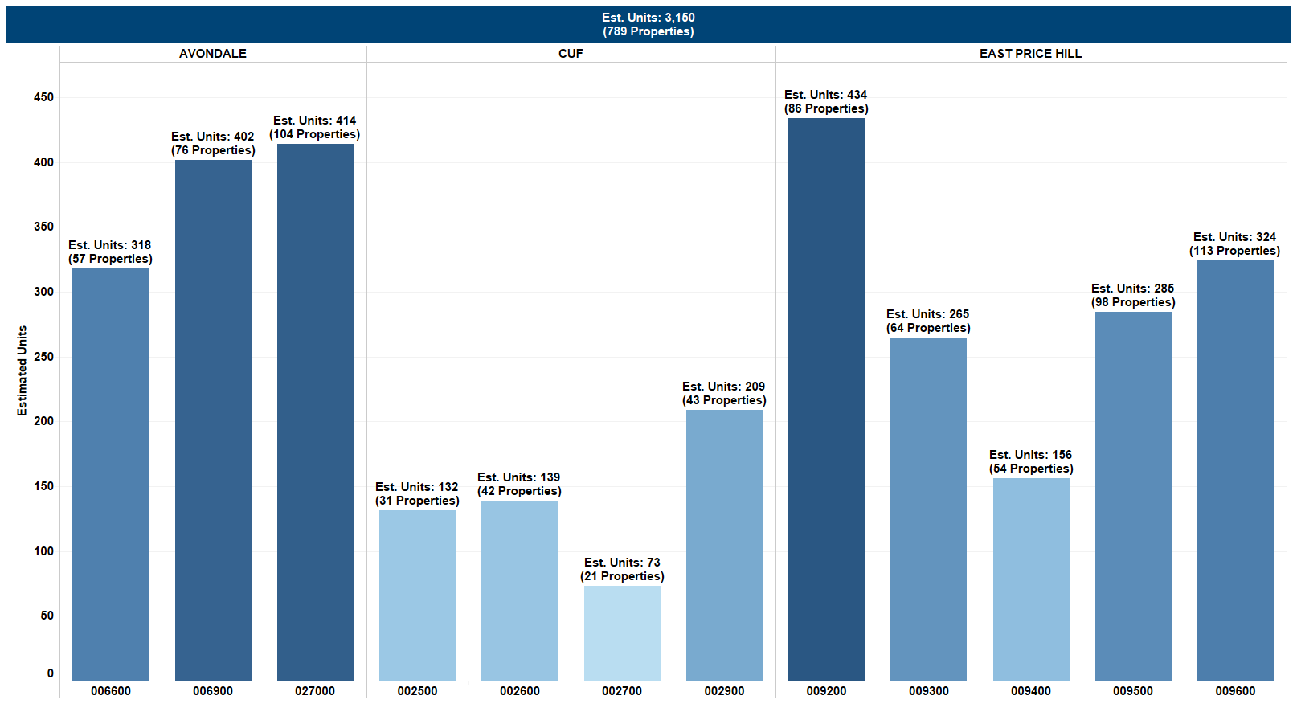

Above are the current estimated properties (units) that would qualify for the program.

The City will explore the feasibility of creating a unique indicator that would be depicted on [www.cincycodeenforcement.com](http://www.cincycodeenforcement.com).

**How can the program be productive in its goal of addressing real public health and safety issues without putting additional burden on otherwise responsible property owners?**

2 Code Violations is not a significant hurdle to clear given code violations can be issued for things as minor as front yard parking or a sidewalk that’s cracked or been displaced by a tree root by 1 inch. Minor violations like these would however result in a property having to pay a $100 inspection fee and trigger inclusion in a program that was never intended to include them.

This problem can be addressed in two ways: 1) spell out the specific nature of code violations that trigger inclusion in the program to eliminate ones that don’t negatively impact the public health, safety and welfare ; or 2) allow for a “Courtesy Notice & Cure Period” prior to a formal Code Violation being issued. The first solution seems overly difficult, while the second option seems more than reasonable. We would suggest a 30 day cure period whereby a property owner is informed of the potential Code Violations and given 30 days before a formal Code Violation is issued.

The scope of the program is meant to address open violations on the property, and not future violations. Those that receive orders on their property generally have 30 days to abate the issues on the property, therefore a cure period is built into the existing system.

The City of Cincinnati operates on a complaint-based approach. All complaints are field verified by an inspector. Approximately 60% of complaints are determined to be valid and result in a notice of violation being issued to the property owner. The other 40% are determined to be invalid and are closed.

ORDERS – Orders are merely a notice that code violations that were observed on the property and lists, a description of the defect, the corrective action necessary, and the code section that covers the violation. This notice also gives the property owner a timeframe to respond, information on how to appeal the notice, and requests the owner contact the inspector at the email or phone number of the inspector provided. There is no fine or penalty associated at this point.

VIOLATIONS – If the condition of a portion(s) of a building violates the standards set in chapter 1117 of the Cincinnati Municipal Code it is considered a violation. Orders can be issued to a property owner if one or more violations are found on a property.

Unless the condition of the property worsens prior to the re-inspection additional orders would more than likely not be issued to the property owner. Again, prior to the initial inspection the property owner will receive an informational packet that includes a self-inspection checklist. It is recommended that the property owner utilize the checklist to abate any issues prior to the inspection and therefore greatly reduce the chance of additional orders being issued.

The explanation of Orders vs Violations is very helpful and we’re satisfied.

We would like the first trigger (2 Code Violations) to be more specific and only apply to safety and quality of life related violations.

This is addressed in section 1127-07.7 # 5 – Has been subject of two or more orders issued within a twelve-month period by the department of buildings and inspections, the Cincinnati fire department, and/or the board of health or its designee for building, housing, fire prevention, public health, quality of life, or health code violations;

**The definition of “Code Compliant” is not clear as it relates to the timeline.**

Section 1127-07.13 (1) states that “properties found to be code compliant shall be issued a certificate ~~and shall be inspected again after forty-eight months, prior to the expiration of the certificate or prior to the expiration of the Pilot Program, whichever comes first~~.”

Given that the entire Pilot Program only last 48 months, it is literally impossible for another inspection to occur once a property has been determined to be Code Compliant… there is no “whichever comes first”. Therefore, we would suggest striking out the portion noted above.

This re-inspection criteria has been included in the event the program is extended and to assess the feasibility and appropriateness of a four-year certification.

Understood.

**Are there periodic reviews of rental properties over the four-year program beyond the initial application period?**

The legislation wasn’t clear. We believe the intent is that there would be a periodic 12 month “look back” (perhaps quarterly), but the legislation wasn’t clear to us. It appeared that it should be addressed in Section 1127-07.9, but that only refers to the first 30 days after passage of the legislation.

For those properties that are code compliant and have obtained a certificate, no additional inspections under this ordinance will occur. However, should a property become the subject of a new service request, inspections may occur as they would with any other property.

Can a property be entered into the program anytime after the program starts or just at inception? The language wasn’t completely clear.

A property will enter the program if/when they meet one or more of the nine criteria. This can be anytime after the implementation of the program.

**How does the program address properties of different scale?**

Section 1127-0.7.7 (6)

We believe this subsection needs to be changed to accommodate the varying scales of “Residential Rental Property” as defined in the legislation. The trigger of “4 or more validated complaints” in a 12 month period is reasonable for a typical single family rental building. It is not reasonable for a large multi-family project that could have 200 + units. We suggest a more graduated number of validated complaints relative to the number of units in a property.

Section 1127-07.11 (d)

By stating that “all dwelling units in a Residential Rental Property” shall be inspected, that means that if one unit of a 200 unit complex has 2 code violations, the entire property is subject to inspection. This would mean $100/unit x 200 units ($20,000) for something relatively insignificant.

For properties that have multiple buildings, the determination to inspect would be made on a building-by-building basis. The proposed method was initially suggested by the Apartment Owners Association after review of the first proposed RRI program in 2016. It was requested that the program become more narrowed, and not to require every rental unit be inspected under the program.

Understood. In meeting with Councilmember Landsman, it was suggested that there might be a per property cap on inspection fees. This would seem reasonable.

An example of this would be if a complex has five buildings, but only buildings #1 and #3 have open orders; buildings #2, #4, and #5 would not be subject to inspection. Therefore, the property owner would only be responsible for paying the inspection fees for the number of units in buildings #1 and #3.

As you can see, when there is a large complex the program will focus only on the buildings that have known issues. By taking this approach it removes the disproportionality of the fees charged to large complexes if the property is at least minimally maintained.